Task 1. Create a Workbench Notebook
- In the Google Cloud console, from the Navigation menu (), select Vertex AI > Dashboard.
- Click Enable All Recommended APIs.
- In the Navigation menu, click Workbench.
At the top of the Workbench page, ensure you are in the Instances view.
- Click Create New.
- Configure the Instance:
  - Name: lab-workbench
  - Region: Set the region to us-east4
  - Zone: Set the zone to us-east4-b
  - Advanced Options (Optional): If needed, click "Advanced Options" for further customization (e.g., machine type, disk size).
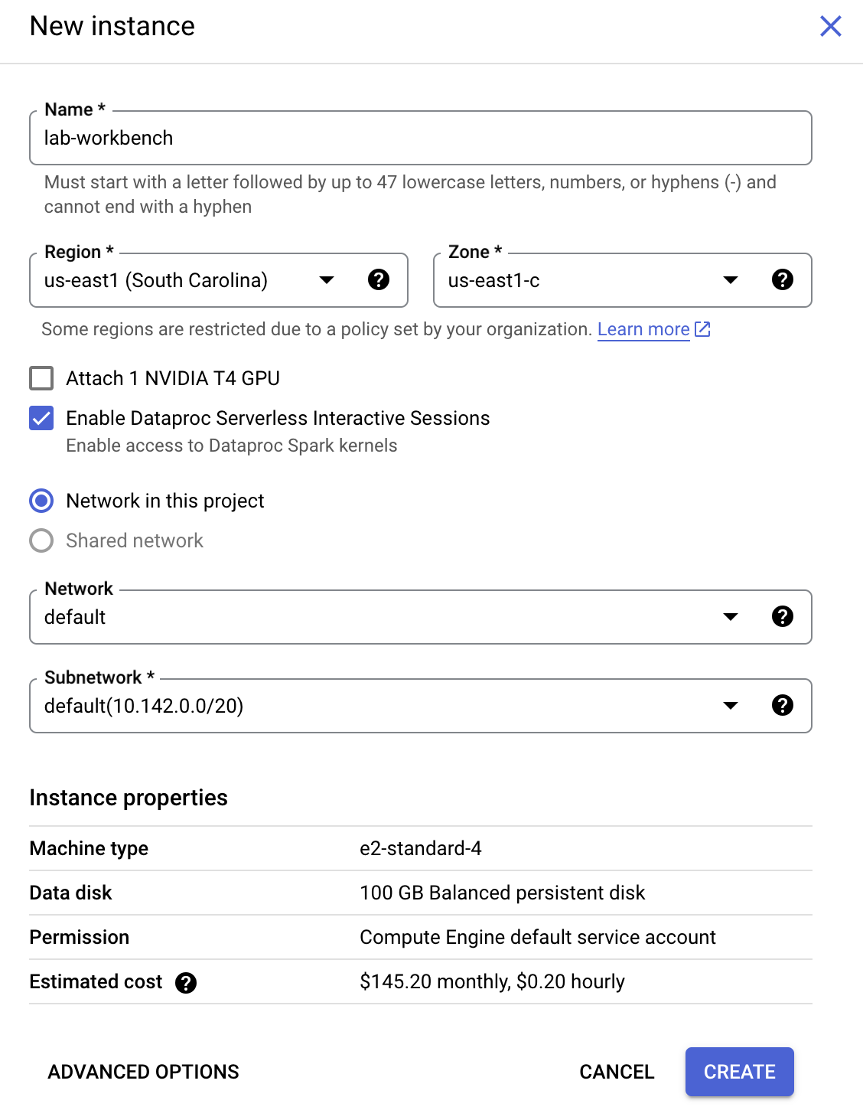
- Click Create.
This will take a few minutes to create the instance. A green checkmark will appear next to its name when it's ready.
- Click Open Jupyterlab next to the instance name to launch the JupyterLab interface. This will open a new tab in your browser.
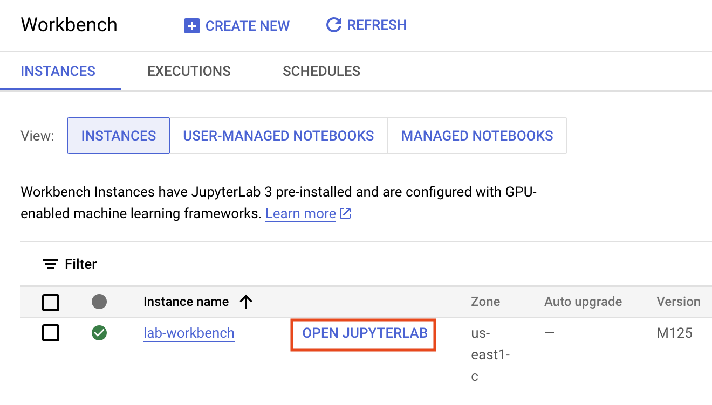
- Click the Python 3 icon to launch a new Python notebook.
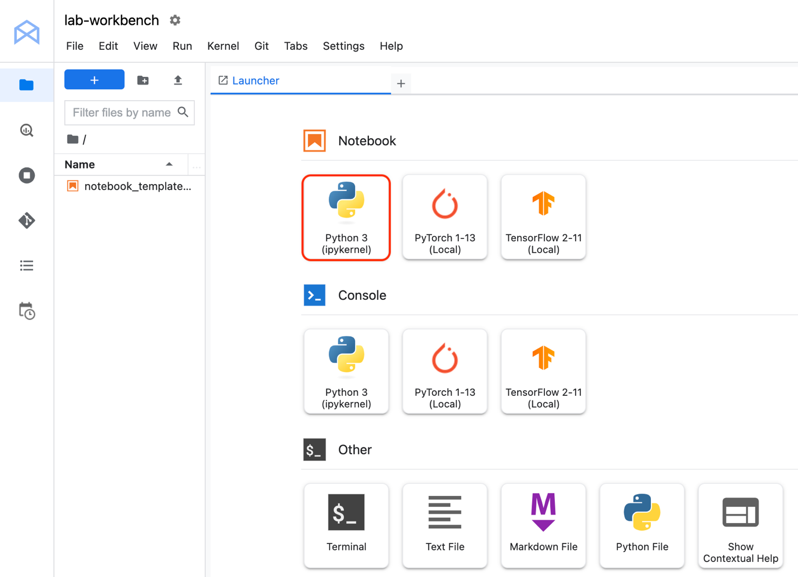
- Right-click on the Untitled.ipynb file in the menu bar and select Rename Notebook to give it a meaningful name.
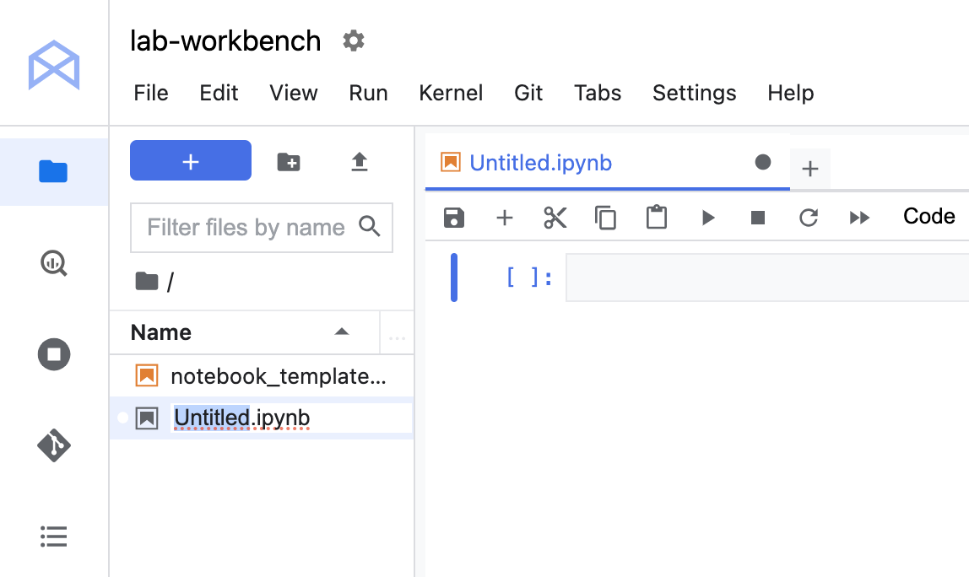
Your environment is set up. You are now ready to start working with your Vertex AI Workbench notebook.
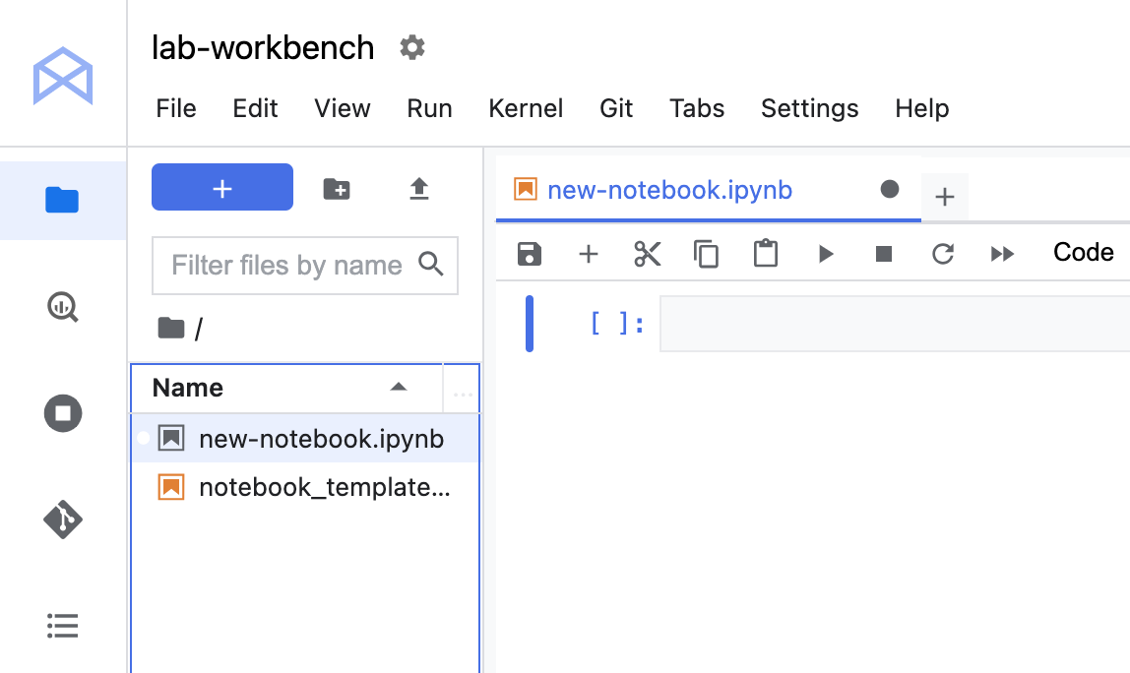

Task 2. Clone a repo within your Vertex AI Notebook instance
The GitHub repo contains both the lab file and solutions files for the course.
- Copy and run the following code in the first cell of your notebook to clone the training-data-analyst repository.
!git clone https://github.com/GoogleCloudPlatform/training-data-analyst
Copied!
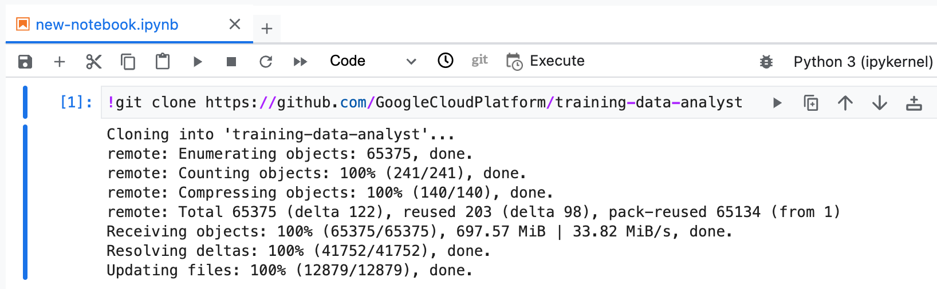
- Confirm that you have cloned the repository. Double-click on the training-data-analyst directory and ensure that you can see its contents.
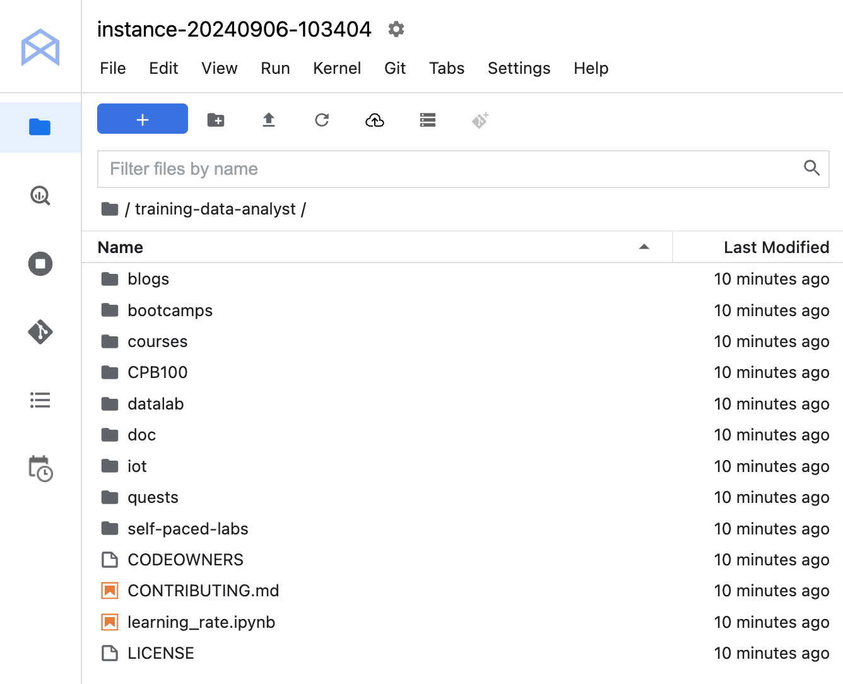
- In the notebook interface, navigate to training-data-analyst > courses > machine_learning > deepdive2 > launching_into_ml > solutions and open workbench_explore_data.ipynb.
- In the notebook interface, click on Edit > Clear All Outputs (click on Edit, then in the drop-down menu, select Clear All Outputs).
- In the Select Kernel dialog, choose Python 3 from the list of available kernels.
- Carefully read through the notebook instructions.
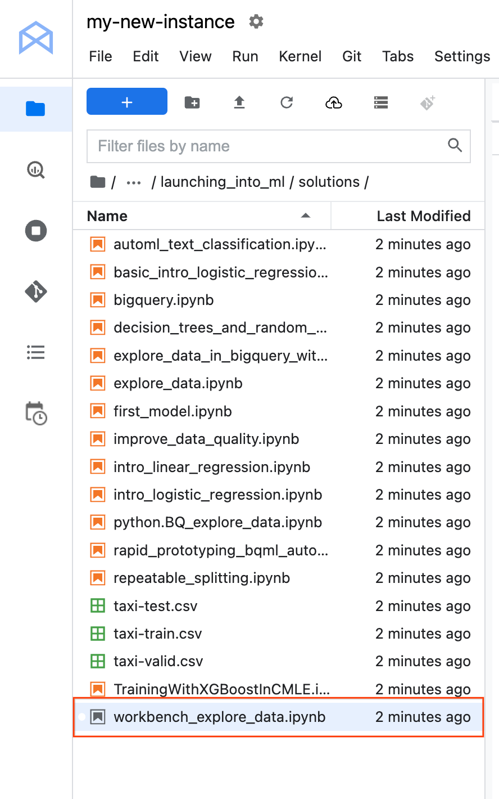

Congratulations!
In this lab you learned how to:
- Create a Workbench Instance Notebook
- Clone a GitHub repository
- Connect to a BigQuery dataset
- Perform statistical analysis on a Pandas Dataframe
- Create Seaborn plots for Exploratory Data Analysis in Python
- Write a SQL query to pick up specific fields from a BigQuery dataset.

End your lab
When you have completed your lab, click End Lab. Google Skills removes the resources you’ve used and cleans the account for you.
You will be given an opportunity to rate the lab experience. Select the applicable number of stars, type a comment, and then click Submit.
The number of stars indicates the following:
- 1 star = Very dissatisfied
- 2 stars = Dissatisfied
- 3 stars = Neutral
- 4 stars = Satisfied
- 5 stars = Very satisfied
You can close the dialog box if you don't want to provide feedback.
For feedback, suggestions, or corrections, please use the Support tab.
Manual Last Updated November 25, 2024
Lab Last Tested November 25, 2024
Copyright 2022 Google LLC All rights reserved. Google and the Google logo are trademarks of Google LLC. All other company and product names may be trademarks of the respective companies with which they are associated.

